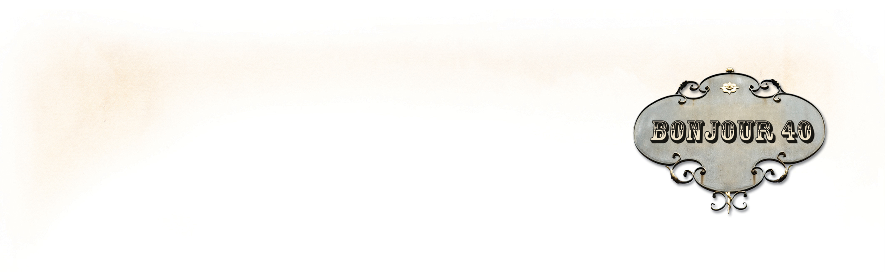
PRESS RELEASE
Virginia Self-Published Author
Wins Three Independent Book Publishers Awards:
Showcases Changes in Self-Publishing

RICHMOND, VA—May 7, 2013—Richmond author, Karen A. Chase, has won three independent book publishing awards in two competitions for her first book, Bonjour 40: A Paris Travel Log (40 years. 40 days. 40 seconds.). In both competitions, her self-published book competed against small- to mid-sized independent publishers, university and museum presses, and corporations that publish fewer than 50 titles a year.

Bonjour 40 won an IPPY Silver Medal for best Travel Essay in the Independent Book Publishers Award, and in the 2013 Next Generation Indie Book Awards it won a Winners Medal for Best Design Non-fiction, and a Finalist Medal for Best Travel/Travel Guide.

“Independent publishers are growing in number, and the quality of their work is increasing,” said IPPY awards director Jim Barnes. The 2013 IPPY awards had over 5000 published works from 2500 publishers. While 29 medalists came from university presses and 9 from museums, equally surprising was that over a dozen of the winners were self-published.

Ms. Chase said, “To see self-published books winning alongside books produced by traditional independent publishing houses, is a wonderful statement that the stigma of self-publishing is changing. Self-published authors are striving to create books with a professional level of writing, editing, design, and production. These awards help provide industry recognition for our efforts.”

Entirely self-published, Bonjour 40 was written, design and published by Ms. Chase and includes 132 full-color pages with over 100 of her own professional photographs. She worked with Kristen Weber and April Michelle Davis to professionally edit the manuscript.

Contact: Karen A. Chase

540-819-4008 ~ kac@karenachase.com

* * *

Karen A. Chase is a freelance writer of historical fiction, poetry, and non-fiction, and owner of 224 Pages. Bonjour 40: A Paris Travel Log (40 years. 40 days. 40 seconds.) is her first book. It is a collection of humorous and insightful tales about Paris, writing, photography set during her month-long trip to turn forty in the City of Lights.

The e-book version of Bonjour 40 released in 2011, was an eLit Silver Medal for Best Non-fiction Travel/Essay e-book, and Ms. Chase also won an eLit Silver Medal for Best Book Trailer, and an eLit Gold Medal for Best Author Website. The IPPY Awards are presented by Jenkins Group Inc., a Michigan-based book publishing and marketing services company. And The Next Generation Indie Book Awards is the largest Not-for-Profit book awards program for indie authors and independent publishers.

Book details and author website – http://karenachase.com
View the trailer for Bonjour 40 on YouTube (also on KarenAChase.com)
Book Retail Site: Bonjour 40 on Amazon

