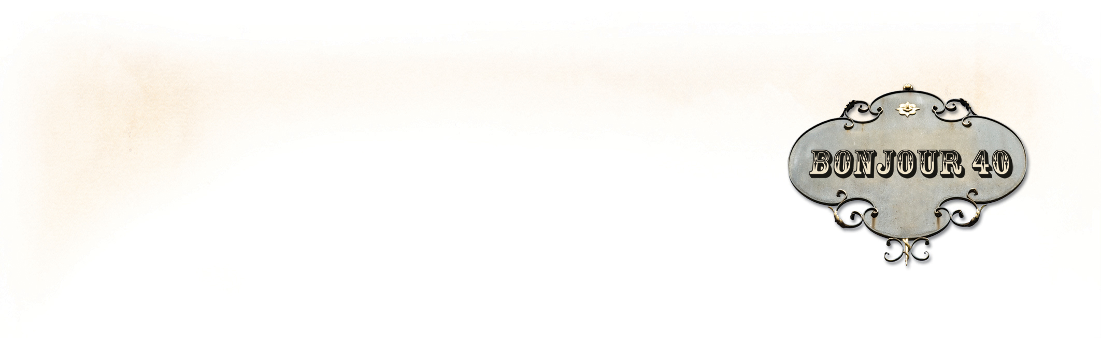
PRESS RELEASE
Self-Published Doesn’t Mean Unfit For Publication
Virginia Self-Published Author
Wins Fourth Independent Publishing Award

RICHMOND, VA—May 20, 2013—Richmond author, Karen A. Chase, has won as a finalist in the International Book Awards. This is the fourth award in 2013 for her first book, Bonjour 40: A Paris Travel Log (40 years. 40 days. 40 seconds.). In all competitions, her self-published book competed against small- to mid-sized independent publishers, university and museum presses, and corporations that publish fewer than 50 titles a year.

Bonjour 40 also won an IPPY Silver Medal for best Travel Essay in the Independent Book Publishers Award, and in the 2013 Next Generation Indie Book Awards it won a Winners Medal for Best Design Non-fiction, and a Finalist Medal for Best Travel/Travel Guide.

Jeffrey Keen, president of USA Book News who hosts the competition says of the awards, “The 2013 results represent a phenomenal mix of books from a wide array of publishers throughout the world.” Over 1000 entrants submitted not only books but marketing materials. Chase's self-published book was among those selected by a "distinguished panel of industry judges who bring to the table their extensive editorial, PR, marketing, and design expertise."

Ms. Chase said, “Self-published authors are striving to create books with a professional level of writing, editing, design, and production. These awards help provide industry recognition for our efforts, especially when we compete and win alongside books produced by traditional independent publishing houses. Self-published no longer means unfit for publication.”

Bonjour 40 was written, designed and published by Ms. Chase and includes 132 full-color pages with over 100 of her own professional photographs. She worked with Kristen Weber and April Michelle Davis, also from the Richmond area, to professionally edit the manuscript.

Contact: Karen A. Chase

540-819-4008 ~ kac@karenachase.com

* * *

Karen A. Chase is a freelance writer of historical fiction, poetry, and non-fiction, and owner of 224 Pages. Bonjour 40: A Paris Travel Log (40 years. 40 days. 40 seconds.) is her first book. It is a collection of humorous and insightful tales about Paris, writing, photography set during her month-long trip to turn forty in the City of Lights.

The e-book version of Bonjour 40 released in 2011, was an eLit Silver Medal for Best Non-fiction Travel/Essay e-book, and Ms. Chase also won an eLit Silver Medal for Best Book Trailer, and an eLit Gold Medal for Best Author Website. The IPPY Awards are presented by Jenkins Group Inc., a Michigan-based book publishing and marketing services company. And The Next Generation Indie Book Awards is the largest not-for-profit book awards program for indie authors and independent publishers. The International Book Awards are held by USA Book News.

Book details and author website – http://karenachase.com
View the trailer for Bonjour 40 on YouTube (also on KarenAChase.com)
Book Retail Site: Bonjour 40 on Amazon

